Service Specification for Community Pharmacists undertaking the Hillingdon AF Service
March 2023
Version 3.0

Written by:
Zainab Khanbhai, Service Lead, Primary Care AF Hub
Contact details: z.khanbhai@rbht.nhs.uk
Review date: October 2024

Version 1: May 2018
Version 2: Oct 2020
Previous authors- Zainab Khanbhai and Sally Manning,
This material forms part of a joint working partnership with Daiichi Sankyo UK
Contents

Service description: 3
Service particulars: 4
Aims and intended service outcomes: 4
Service outline: 4
1. Inclusion and exclusion criteria 4
Pharmacy Inclusion Criteria: 4
Participant Inclusion Criteria: 5
Exclusion criteria 5
2. Participant selection: 5
3. Consent: 5
4. PharmOutcomes –before the Kardia ECG is recorded 5
5. Recording the participants ECG using the Kardia monitor. 9
6. Interpreting the results: 11
7. PharmOutcomes: After the Kardia ECG is recorded 12
8. Heart rate, blood pressure and symptoms 14
a) Heart rate: 14
b) Blood pressure reading 14
c) AF related symptoms 15
Referral for NMS 15
Appendix 1: Consent form 16

Service description:
- The Capture AF service involves the community pharmacy identifying eligible participants, undertaking an electrocardiogram (ECG) using a Kardia monitor (1 lead ECG) and completing a service tool on PharmOutcomes
- The pharmacist will refer any participants who are not known to have Atrial Fibrillation (AF) with a “possible AF” ECG to the primary care AF hub
- The pharmacist will refer any participants with an “unclassified” or “unreadable” ECG to the primary care AF Hub.
- The pharmacist will identify and refer any participants with side effects or adherence problems with anticoagulation to the community AF hub
- The pharmacist will refer any participants with previously diagnosed AF and a high symptom burden to the primary care AF hub
- The pharmacist will provide support and advice to the participant if a “possible AF”, “unclassified” or ”unreadable” ECG is identified
- The pharmacist will review any newly diagnosed AF participants started on anticoagulation via the New Medicines Service (NMS) and provide advice and counselling in order to improve adherence

Service particulars:
- The service will run from XXXXXX after which point results will be analysed and reported back to stakeholders by service leads.
- Pharmacies will be reimbursed £11 for each participant recruited (this payment is separate to the NMS payment and is reimbursed to pharmacies by Hillingdon Confederation)

Aims and intended service outcomes:
- Increase the detection of previously undiagnosed, often asymptomatic AF
- Increase anticoagulation in participants with a CHA₂DS₂VASc score of 1 or above potentially reducing the incidence of strokes
- Facilitate the direct, early referral to a dedicated community AF hub
- Improve participant knowledge, understanding of their medications and adherence to treatment
- Improve participant access to pharmacy health initiatives and facilitate engagement of patients with community pharmacists
- Allow community pharmacists to develop clinical skills facilitating the expansion of their current roles, supporting continuing professional development

Service outline:

Inclusion and exclusion criteria

Pharmacy Inclusion Criteria:
- Completed the required training for the Capture AF service
- Consultation room in the Pharmacy
- Pharmacy has Wi-Fi connection
- Pharmacy has access to PharmOutcomes
- Pharmacy located in the London borough of Hillingdon

Participant Inclusion Criteria:
- Over the age of 65 with one or more of the following conditions:
  - Coronary heart disease
  - Diabetes
  - Hypertension
  - Heart failure
  - Stroke/TIA
  - Peripheral artery disease
  - Previously diagnosed AF

Exclusion criteria
- Participant under the age of 65 years
- Participant does not consent to be part of the service
- Pharmacy outside of the Hillingdon area
- Participant registered with a GP outside of the Hillingdon area

2. Participant selection:
- Ensure participant meets the inclusion criteria. Provide participant with leaflet explaining the service.
- Participant may be selected by
  - Self-requesting for the Capture AF service
  - Pharmacy dispensing system flags participant is eligible for standard cardiovascular Medicines Use Review
  - Participant receives routine MUR
  - Participant selected during routine counselling session
  - Opportunistic when participant collects their repeat medication

3. Consent:
- Invite participant to the consultation room
- Gain verbal consent and document on PharmOutcomes.
- Read through the consent form (appendix 1) with the participant and answer any questions the participant may have

4. PharmOutcomes –before the Kardia ECG is recorded
Once the participant has consented to take part in the service, use the Capture AF service on PharmOutcomes to document the participant information and for sending a referral to the Primary care AF hub admin team (a message will be displayed on PharmOutcomes as to when a referral has been triggered).
There is no visible consent question within the template, instead there is a hidden question within the template which states ‘A consent has been completed outside of PharmOutcomes to allow completion of the service and information to shared with your GP/Hillingdon Confederation or the Royal Brompton and Harefield NHS Foundation Trust’. It is configured as ‘consent granted’ outside of PharmOutcomes.
Using PharmOutcomes to undertake the Capture AF service
- Open the webpage https://pharmoutcomes.org/pharmoutcomes/
- Enter username and password
- Select ‘Services’ tab on the top left hand side of the page
- Select ‘Capture AF service’
- Enter your security password
- When using PharmOutcomes for the first time for the Capture AF service enrol as a new practitioner. Enter your name in the box and select “New Practitioner”, then click on the “enrol me” button
- If you have already enrolled, then start typing your name in the box and select from the drop down list

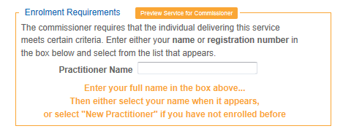(PharmOutcomes screenshot)

- Fill in participant demographics, contact number and GP practice details
- GP practice can be searched by name, postcode or location and will appear as a drop down list

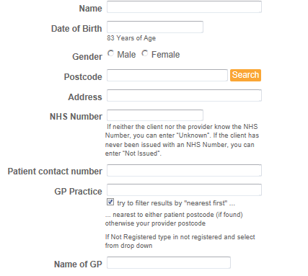

(PharmOutcomes screenshot)

- Confirm that the participant is eligible to take part in the service by ticking the relevant risk factors
- Tick the box to confirm that risk factors are present. This will then reveal the next set of questions. All boxes must be filled, this will allow the CHA₂DS₂VASc calculator to generate the CHA₂DS₂VASc score (see point (l) below)
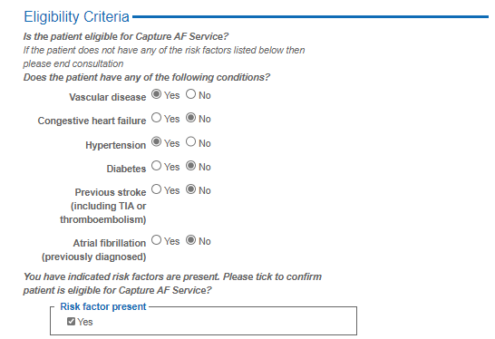
(PharmOutcomes screenshot)
l)CHA₂DS₂VASc score

- Click on the CHA₂DS₂VASc score calculator
- The gender and risk factors will be automatically entered into the calculator according to what has been entered.
- Check that these are correct and close the table
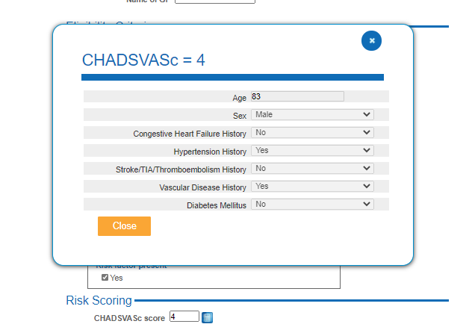
(PharmOutcomes screenshot)
m) Next enter if the participant is taking any anticoagulation and if they have any allergies
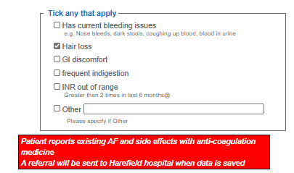

(PharmOutcomes screenshot)

  - If no anticoagulant then go to the next question
  - If taking an anticoagulant then there will be extra prompt regarding side effects.
  - If there is a side effect with anticoagulation documentation of the type of side effect will be required. This will trigger a referral.
  - If 'other' selected please provide a brief description of said side effect, please do not enter any medication names.
n) If there is a problem with compliance, document the compliance issue here. Please do not record any medication names if 'other’ selected.
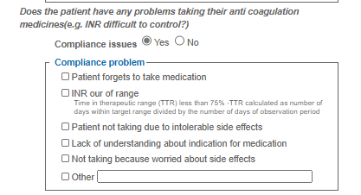
(PharmOutcomes screenshot)

Now record the ECG before continuing with the rest of the questions on PharmOutcomes.

5. Recording the participants ECG using the Kardia monitor.
Assessment process; using the Kardia monitor
- Before each assessment the device should be wiped down using standard clinical alcohol wipes. The participant must use alcohol gel/hand sanitiser before and after using the Kardia monitor. This reduces the risk of infection (COVID -19 plus other infections) and improves connectivity with the sensors.
- Open the Kardia pro application. You will be directed to the homepage.
- From the homepage select “record your EKG”


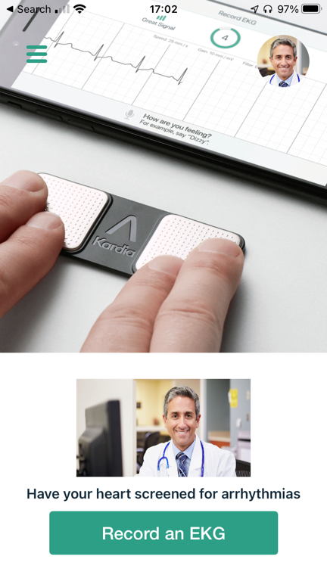

(KardiaPro application screenshot)
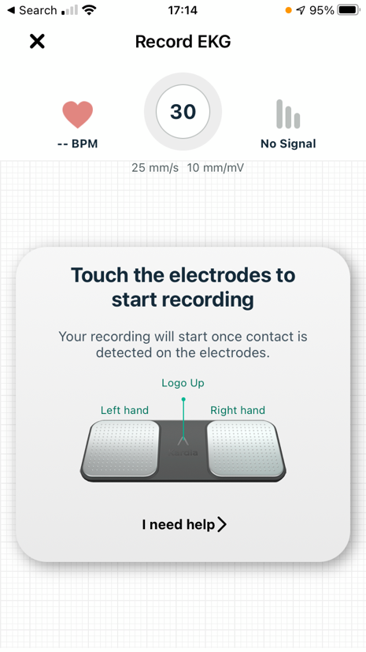
- For the reference enter in the NHS number followed by your pharmacy name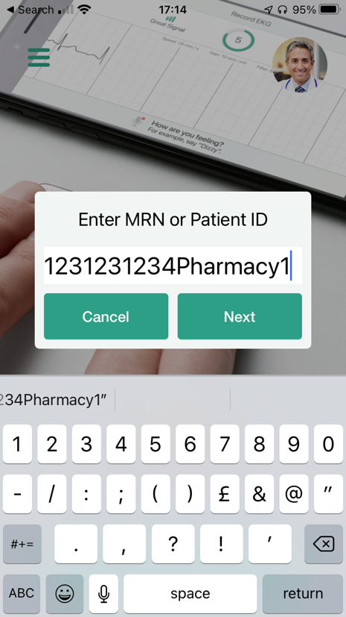

(KardiaPro application screenshots)

- To ensure a good signal hold the Kardia monitor close to the microphone on the tablet
- Instruct the participant to rest their fingers on the pads with the Kardia device resting on the desk
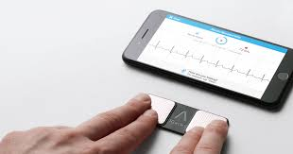

Image: KardiaMobile EKG Monitor - Instant EKG on Your Phone | AliveCor – AliveCor, Inc.

- To ensure a better quality recording the participant should remain still, does not move their hands or talk and is asked to ‘relax their shoulders’. Movement, background noise and muscle tension will affect the quality of the reading
- Scroll to the guest EKG option and tap ‘record now’. The screen will change to simulated ECG trace paper
- On the top left hand corner, green signal bars will show that the device is communicating correctly. Move the Kardia monitor closer if the bars are small to improve the communication signal
- The timer will count down from 30 seconds. When the timer reaches zero, the ECG will be interpreted and the results given on screen
- Once 30s has elapsed the ECG trace has been recorded and the result and heart rate will be available
- Once complete the Kardia ECG will be automatically uploaded to the Kardia station GDPR compliant cloud which will be accessed by the Primary care AF team.

6. Interpreting the results:
Once the 30 second recording is completed you will be presented with an automated assessment of the participants ECG
Possible outcomes:
1: Normal –
- No previous history of AF
No further action needed. Save the information. Refer via PharmOutcomes Capture AF service primary care AF hub for further questions on general health.
Previous AF history
Explain to the participant that this is a common finding as many patients will ‘flip’ in and out of AF and this is called Paroxysmal AF. Refer via PharmOutcomes Capture AF service Primary care AF hub for further questioning regarding symptom control and anticoagulation.
2: Possible AF
- No prior history of AF
A referral will be generated as participant may have undiagnosed AF.
Reassure participant that this is not a confirmed diagnosis, but simply advise that they require further testing.
Offer the participant Atrial Fibrillation Association (AFA) patient information booklet and relevant preventative advice. Explain that they will be contacted by the Primary care AF hub within 2 weeks to attend a clinic appointment. At the clinic appointment diagnosis will be confirmed, therapy may be initiated .
- Previous AF diagnosis of AF
Reassure the participant that the possible AF ECG is expected as they have a previous AF diagnosis. Refer to PharmOutcomes Capture AF service for further questioning regarding symptom control and anticoagulation.
3: Unclassified, sinus rhythm with wide QRS, Sinus rhythm with PVCs (pre-ventricular contractions) Sinus rhythm with SVEs (supra ventricular ectopics), bradycardia, tachycardia:
Repeat the recording again (suggest a maximum of 3 attempts). Ensure the participant is calm, sits still, does not talk and relaxes their arms and shoulders.
If still unclassified a referral will be sent once consent to refer box has been ticked ‘yes’. Reassure the participant that this is not a confirmed diagnosis, but simply that they will require further testing. Offer the participant AFA patient information booklet and relevant preventative advice where appropriate. Explain that they will be contacted by the primary care AF Hub within 2 weeks and may be asked to attend a clinic appointment.
4: Unreadable:
This means that the Kardia Mobile algorithms have not been able to interpret the reading that has been taken. This may be due to too much background noise, poor connectivity between the patient and the sensors or too much movement in the patient’s limbs.
Repeat the test ensuring that the participant is calm, sits still, does not talk and relaxes their arms and shoulders. It may be useful to moisten the finger tips using hand sanitiser to improve connectivity. In some individuals it will not be possible to record a good quality ECG due to anatomical and physiological differences.
If after 3 attempts to record a good quality ECG, you still cannot get a good quality reading; save the last ECG. Explain that they will be contacted by the primary care AF Hub within 2 weeks and may be asked to attend a clinic appointment.

PharmOutcomes: After the Kardia ECG is recorded
Once the ECG has been taken, record the result onto PharmOutcomes.
- NORMAL ECG: No further action will need to be taken. Complete the rest of the questions.

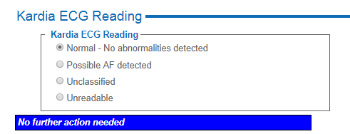
(PharmOutcomes screenshot)
- POSSBILE AF ECG: A statement will displayed indicating that a referral will be sent once the data has been saved to the primary care AF Hub and the reason for the referral. You do no need to send a separate referral. The GP will also be sent information via PharmOutcomes that the referral has been made. Participant consent must be gained before a referral is sent. Complete the rest of the questions.
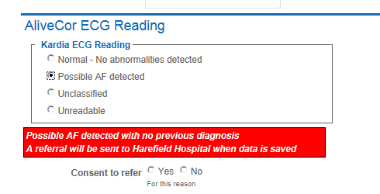
(PharmOutcomes screenshot)
- UNCLASSIFIED ECG: a statement will displayed indicating that a referral will be sent once the data has been saved to the primary care AF Hub and the reason for the referral. You do no need to send a separate referral. The GP will also be sent information via PharmOutcomes that the referral has been made. Participant consent must be gained before a referral is sent. Complete the rest of the questions.
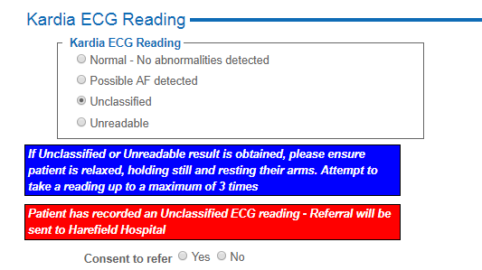
(PharmOutcomes screenshot)

- UNREADABLE ECG: A statement will displayed indicating that a referral will be sent once the data has been saved to the primary care AF Hub and the reason for the referral. Ensure the consent to refer ‘yes’ is ticked. You do no need to send a separate referral. The GP will also be sent information via PharmOutcomes that the referral has been made. Participant consent must be gained before a referral is sent. Complete the rest of the questions.
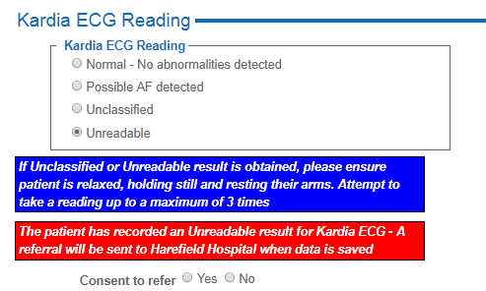
(PharmOutcomes screenshot)

8. Heart rate, blood pressure and symptoms

a) Heart rate:
  - For all ECGs except unreadable* enter in the heart rate.
(*the heart rate box is not displayed on PharmOutcomes for an unreadable ECG as this is often an unreliable reading)
  - If the heart rate entered is less than 50 or greater than 100 a referral to the AF hub will be generated.

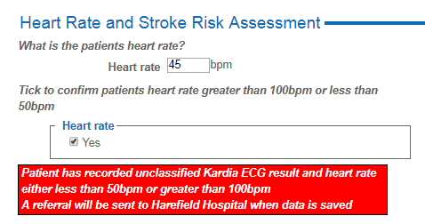
(PharmOutcomes screenshot)

b) Blood pressure reading
This is important to document as anticoagulation cannot be started if a patient has uncontrolled blood pressure.
Please enter a blood pressure reading if possible either by:
- Using a BP machine available
- Asking the patient for a recent record of their blood pressure
If you do not have this information, please leave blank
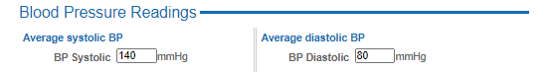

(PharmOutcomes screenshot)

AF related symptoms
- If the patient has a possible AF or unclassified/unreadable ECG you will be prompted to ask about any symptoms that they may have relating to AF. This will help the specialist team ascertain patient AF burden and will enable further questioning during the phone triage process.
- Please enter if the patient is already under the care of a cardiologist, as this may change their treatment pathway.
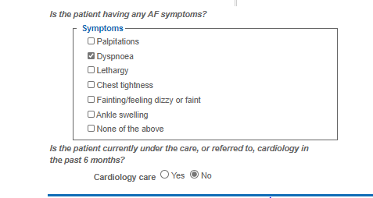
(PharmOutcomes screenshot)
The Capture AF service form is now complete. Once the “save” button is clicked, any referral will be sent to the primary care AF Hub and this entry will be recorded (pseudo-anonymised) and saved on the PharmOutcomes database.

Referral for NMS
- Any participants that are subsequently seen by the specialist pharmacist or arrhythmia nurse specialist and initiated on anticoagulation will be referred back to the original community pharmacy via an NMS referral.
- A message will appear on PharmOutcomes page of the selected community pharmacy.
- The referral should be then processed in the usual way by the community pharmacist as per NMS requirements.

This material forms part of a joint working partnership with Daiichi Sankyo UK

Glossary:
AF – Atrial fibrillation
NMS – New Medicines Service
PharmOutcomes: a secure clinical service platform for community pharmacies and commissioners to capture outcomes data for local and national services.
Primary Care AF Hub: Patients referred from the community pharmacist will be seen in this Hub which is run by specialist pharmacists, supported by GPs and secondary care.
Hillingdon AF Service: Previously known as Capture AF service. This term encompasses the whole service design from community pharmacists identifying potential AF, to AF hub where patients are seen once referred by the community pharmacist and secondary care team who will support review of complex patients.

